**REXELPAY**

TAKE HOME TASK

Tested By:

AMAYINDI LYNN

Date Tested:

16th December, 2020

Contents

Scope of Task 3

Introduction 3

Challenge 1 3

Challenge 2 4

Challenge 3 4

# Scope of Task

## Introduction

Below is the list of tasks that I have selected to work with:

1. Challenge 1
2. Challenge 2

So, for the first challenge, the goal is to find the defects that exist within the screenshot displayed below:

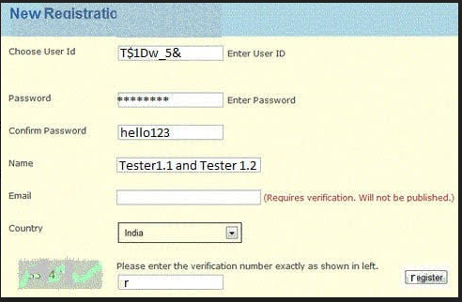

### Challenge 1

Looking at the UI of this page, there are some things that do not sit properly with the UI; which in turn can affect the user experience for the application. These are:

1. The page title does not clearly read or state the function of the page, because the title is incomplete; so it should read “Registration”
2. Since the value of the “Password” entry is hashed, then the value of the “Confirm Password” should be hashed too
3. The “verification number” displayed in the left is not clear enough; thereby making it difficult for the user to know the values displayed therein
4. The “Enter User Id” and “Enter Password” hints that appear at the right of the “Choose User Id” and “Password” fields respectively can be inserted as hints in the entry field to further improve the organization of the page layout
5. The text on the “register” button should read “Register”
6. The caption “Requires verification. Will not be published” should be moved right below the “Email” field to improve and properly manage the page layout and user experience
7. The register button should be further increased in size; to aid visibility and for users with small screen resolutions, so they don’t have difficulties clicking the button
8. The hashed “Password” value does not sit inside the entry field rather it overlaps on the entry boundary

### Challenge 2

In this section the goal is to give a detailed defect report of this bug:

**After logging into Gmail, it navigates to Google.com**

So, the statement above was the bug found during a test; so first:

#Issue 1

Bug

After logging into Gmail, it navigates to the Google.com

Precondition

-Need to have a working operating system

-This test was carried out using the chrome browser

-Using a mobile device with mobile data on 3G network

Steps To Reproduce

1. Launch the browser
2. Search the Gmail login page
3. Navigate to the login page
4. Input the Username and Password
5. Click on the “Login”

### Challenge 3

This task is aimed at seeing how to improve an existing design to make it more user friendly and precise. The screenshot that needs to be improved upon is displayed below:

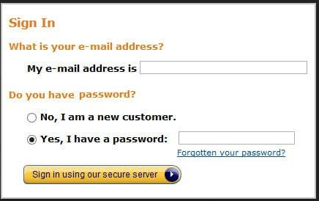

So, this is actually a very interesting UI that was designed to make it easy for the user to understand what he needs to do at every point in time which is too detailed. In as much as it is meant for the user to understand, but it is not user friendly and which in turn doesn’t improve user’s experience when using the application because there are so many details.

The modifications will be:

1. For the page title, it looks fine in terms of text colour, spelling, and visibility
2. As for the question the precedes the prompt for the user to enter email address is not necessary so it should be taken out
3. The prompt message the sits to the left of the email entry field its too lengthy and therefore needs to be modified to just “Email” to improve the layout
4. The prompt message that sits to the left of the password entry field should just be changed to “Password”
5. The password field should come before the radio button that allows new users to register
6. The text box of the email and password do not align
7. The text box for email is bigger than the password field
8. The “Forgotten Your Password?” link should sit after the “Sign in using our secure sever” button
9. The “Sign in using our secure sever” text should read “Sign In Using Our Secure Sever”

So see a suggestion of a page that clearly depicts everything on the afore login page and even added a check box that reads “Remember me” which aids in saving customer login details in case of future login

